# Topic: Network Analytics

**Instructions:**

Please share your answers filled in-line in the word document. Submit code separately wherever applicable.

Please ensure you update all the details:

**Name: _____________ Batch ID:** ___________

**Topic: Network Analytics**

**Guidelines:**

**1. An assignment submission is considered complete only when correct and executable code(s) are submitted along with the documentation explaining the method and results. Failing to submit either of those will be considered an invalid submission and will not be considered as correct submission.**

**2. Ensure that you submit your assignments correctly and in full. Resubmission is not allowed.**

**3. Post the submission you can evaluate your work by referring to keys provided. (will be available only post the submission).**

**Hints:**

1. **Business Problem**
   1. **What is the business objective?**
   2. **Are there any constraints?**
2. **Work on each feature of the dataset to create a data dictionary as displayed in the below image:**

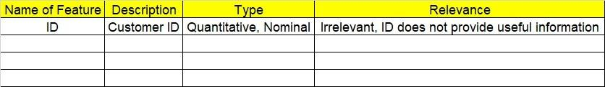

**Make a table as shown above and provide information about the features such as its data type and its relevance to the model building. And if not relevant, provide reasons and a description of the feature.**

1. **Data Cleaning**
2. **Model Building**
   1. **Perform network analytics on the given datasets.**
   2. **Briefly explain the model output in the documentation.**
3. **Write about the benefits/impact of the solution - in what way does the business (client) benefit from the solution provided?**

**Problem Statement: -**

Two datasets consisting of information for the connecting routes and flight halt are provided. Create network analytics models on both datasets separately. Using various network analytics-based measures derive insights for the business to benefit from the data available.

* Create a network using an edge list matrix (directed only**).**
* Column to be used for respective datasets

Flight_halt = ID", "Name", "City", "Country", "IATA_FAA", "ICAO", "Latitude", "Longitude", "Altitude", "Time", "DST", "Tz database time"

connecting routes = "flights", " ID", "main Airport”, “main Airport ID", "Destination ", "DestinationID", "haults", "machinery"

**cohaltsng routes**

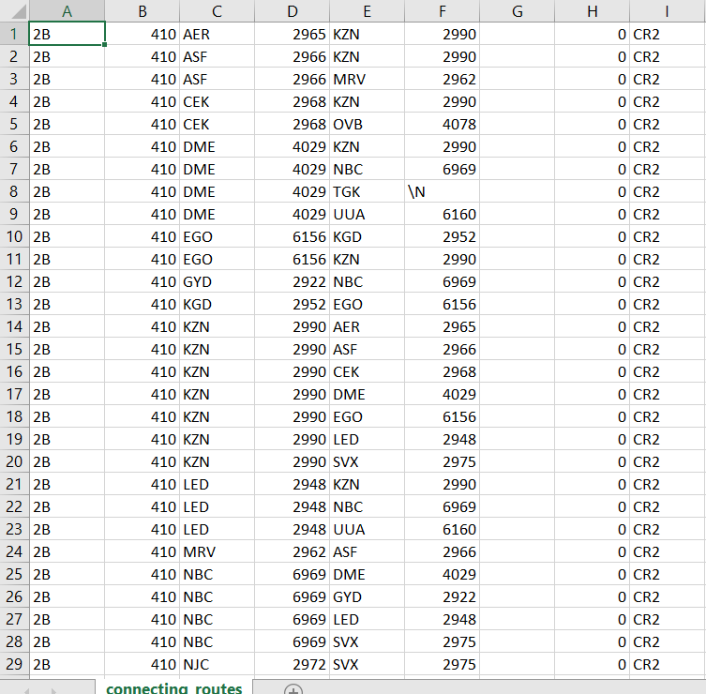

**Flight_hault1**

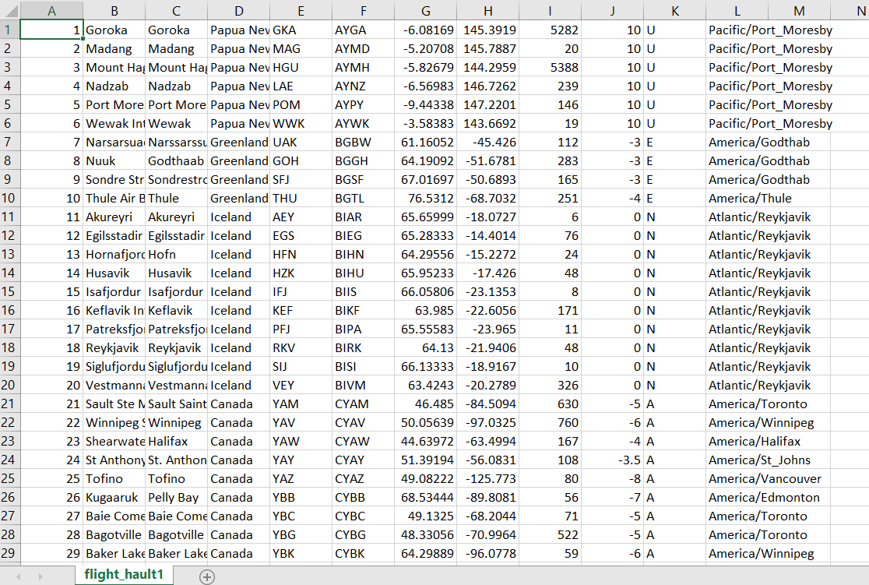

**Problem statement 2:**

There are three datasets given (Facebook, Instagram, and LinkedIn). Construct and visualize the following networks:

* circular network for Facebook
* star network for Instagram
* star network for LinkedIn

Create a network using an adjacency matrix (undirected only). The snapshots of those datasets are given below:

**Facebook**

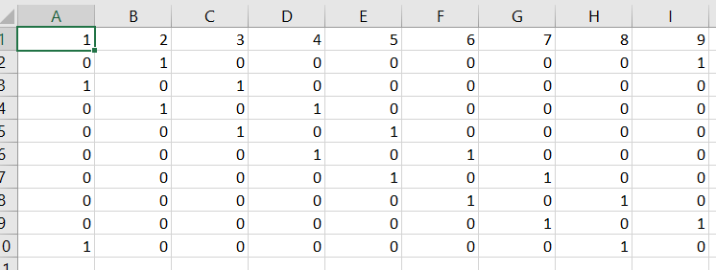

**Instagram**

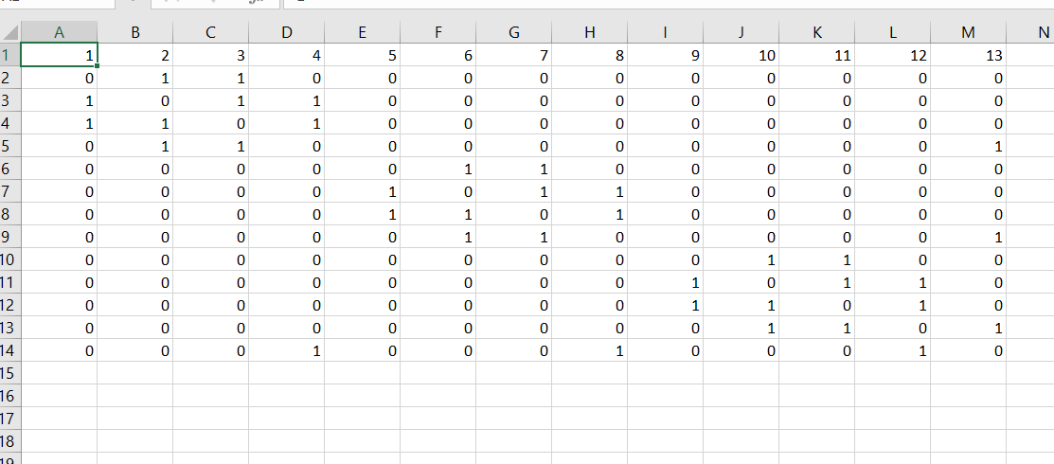

**LinkedIn**

